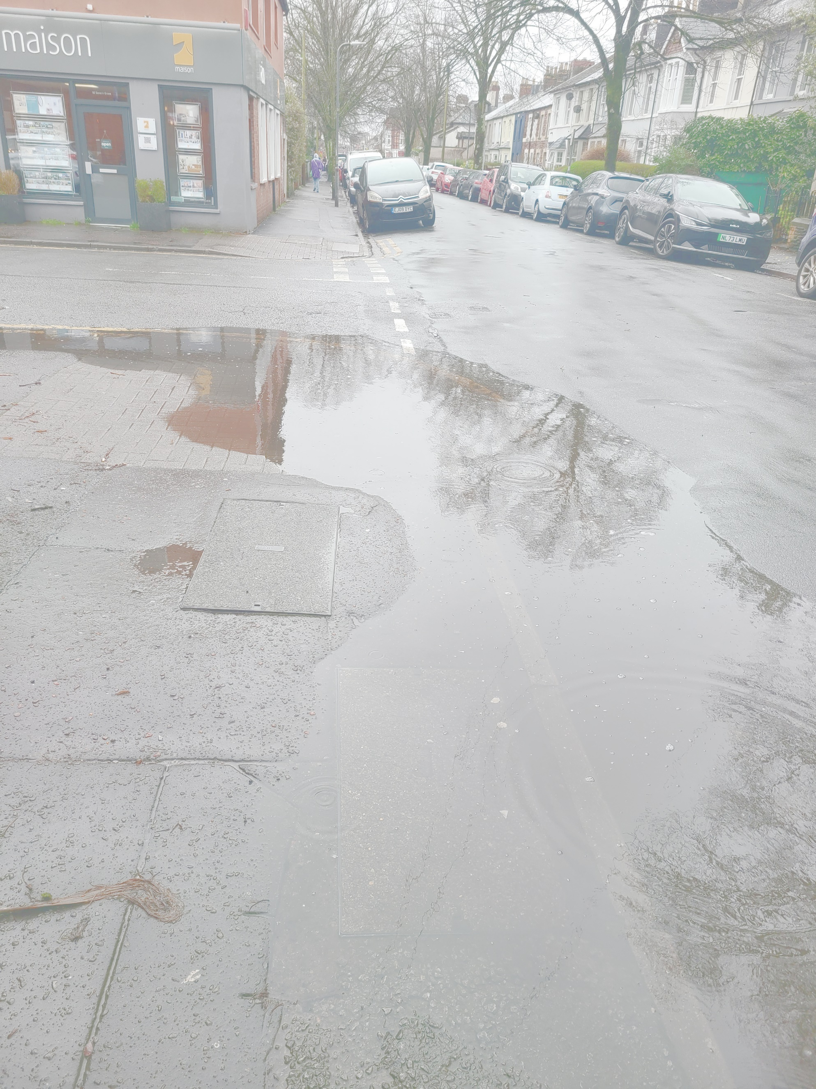
Community flood plan
Severn Grove, Romilly Crescent
and Conway Road, Cardiff

We live in an area where flooding is possible – the last major flood event in 1979 flooded the southern and eastern parts of Pontcanna. Flood defences have been built since then but over recent years climate change has led to more extreme weather events. There are risks of flooding from surface water and river and sea in parts of our area in future years.
In order to prepare for this, a group of local residents have begun to draft a community flood plan to:
- Raise awareness of flood risk.
- Give information and links to websites and resources which can help residents and businesses prepare and act before, during and after flooding.
- Help to coordinate volunteers and action.
To find out more and influence it come to a:
Community event and exhibition
Saturday 21 September 2024. 9.30am-12.30pm.
at
Conway Road Methodist Church meeting room (lower level accessed from Romilly Crescent).
Please come along and tell us what flooding issues and concerns you have.
The full draft community flood plan including maps will be available to view and comment on.
Visit our website for more information on the issues and the plan summary:
www.pontcannafloodplan.org.uk
or click this QR code to access the site:


At the event you will be able to find out:
- The overall risk in the area and how this varies.
- How to find out your flood risk and what you can do to prepare for flooding
- What the community can do to reduce risks and prepare for flooding.

We hope to see you there!

